

**SPELD NZ COURSE  
INTRODUCTION TO SPECIFIC LEARNING DISABILITIES (SLD)**

**(Level 3 NZQA-approved)**

Are you struggling to support a child or adult with dyslexia?

Are you a parent concerned about your child’s learning journey?

Are you a teacher/teacher aide who wants to reach more children in your classroom?

Are you a Learning Support Coordinator taking on a new role?

Are you aware of children who are disruptive, withdrawn, bright but not achieving?

**SPELD NZ’S two-day introductory course is for you!**

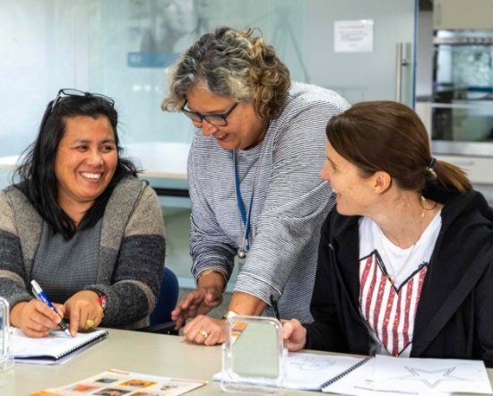

Monday 25 and Tuesday 26 January 2021

9.00am to 4.00pm both days

**Venue**: Independent Living Services (ILS), upstairs conference room, 14 Erson Avenue, Royal Oak, Auckland

**Directors:** Eleanor Boyce and Carin Bosman

**All welcome. Ideal for parents, teacher aides, teachers, RTLB & SENCO.**

This is an introductory course, suitable for those who have limited or no knowledge about SLD.

It gives insights into why specific learning disabilities occur, what it is like to have dyslexia or other SLD   
and offers strategies, tools and tips for helping these learners in the classroom and at home.

For a more in-depth course please talk to us about SPELD NZ’s NZQA-approved Level 5 training.

**Fee: SPELD NZ Members: $250 per person or Early bird payment of $200**

**Non-Members: $350 per person or Early bird price $300**

(Cut off date for Early Bird Price is Friday 8 January 2021)

**Includes: course notes, tea and coffee. Please bring your own lunch.**

**See reverse for enrolment form**

SPELD NZ reserves the right to cancel, or change the content, timing or method of presentation of any course in exceptional circumstances or if the minimum number of registrations is not reached. In general, 7 days’ notice will be given if a course is to be cancelled.

SPELD NZ is not responsible for travel or related costs under any circumstances. Participants may want to consider purchasing trip cancellation insurance in the unlikely event that a programme is cancelled or if the participant cannot attend for personal or professional reasons.

[www.speld.org.nz](http://www.speld.org.nz) Email: [support@speld.org.nz](mailto:support@speld.org.nz) Phone: 0800 773 536, extension 1, then 1  
Facebook & YouTube: SPELD NZ

**SPELD NZ** **Enrolment form – send to support@speld.org.nz**  www.speld.org.nz

**I would like to enrol on the Introduction to Specific Learning Disabilities Course**

**Monday 25 and Tuesday 26 January 2021 – Auckland course 21ISLD11**

Name: ________________________________________________ Phone: _____________________________

Address: ______________________________________________________________________________________

______________________________________________________________________________________________

Email: __________________________________________________ Mobile: _____________________________

Please circle relevant category: I am a Teacher/Teacher aide Parent/caregiver SENCO/RTLB Other:(please specify) _____________________________________

Payments can be made to **SPELD NZ Inc;** PO Box 24617, Royal Oak, Auckland 1345, by direct credit to

ASB Bank 12-3061-0395660-00 (Please include your name and code 21ISLD11 as reference)

All payments must be received by SPELD NZ prior to course commencement.

**Please complete the following information which is required for NZQA statistical purposes.**

**National Student Number/NZQA:** Have you previously enrolled with NZQA? □Yes □No

If ‘yes’ please provide your NSN/NZQA number: _________________________ **Date of Birth**: _______________________________

**Citizenship and residency (verified documents required)**

Tick the box which best describes your citizenship or permanent residency status. If you have dual citizenship, the country of citizenship of the passport used to enter New Zealand.

□ New Zealand citizen □NZ Permanent Resident (State country of citizenship) ___________________________________

□Australian Citizen □Other (please specify) ____________________________________________________________

**To which ethnic group do you belong**? (You may tick up to 3 boxes)

□ NZ European/ European/Pakeha □ Tongan □ Niuean □ Chinese □ Samoan

□ Tokelauan □ Indian □Cook Island Maori □ Fijian

□ Other/ Other Asian/ Other Pacific Island (please specify) ______________________________________________________________

□ NZ Maori (please specify which Iwi you identify with):_________________________________________________________________

**Secondary School**

Name of the last secondary school you attended: ______________________________________________________________________

What was your last year at secondary School? ______________________________________

What is the highest level of achievement you hold from secondary school? Tick one box only

□ No formal secondary qualification or less than 12 credits at level 1

□ Overseas Qualification (includes International Baccalaureate & Cambridge Exams)

□ 14 or more credits at any level □ NCEA Level 1 or School Certificate □ NCEA Level 2 or Sixth Form Certificate □ University Entrance □ NCEA Level 3 or Bursary or Scholarship □ Other____________________________

Year qualification gained: ___________

**Tertiary Study**

Will this be the first year you have ever enrolled in a University, Polytechnic, College of Education, Private Training Establishment or Wananga, either in New Zealand or overseas since leaving school? (Do not include enrolments in Community education programmes).

□ Yes- go directly to next section □ No – what year did you first enrol in tertiary education? _________

**Prior Activity**

What was your main activity or occupation as at 1 October last year?

□ Secondary school student □ College of Education student □ Non employed or beneficiary (excluding retired)

□ House person or retired □ Wage or salary worker □ Overseas (irrespective of occupation)

□ Self-employed □ University student □ Wananga student

□ Polytechnic student □ Private Training Establishment student

**Disability**

Do you live with the effects of significant injury, long term illness or disability? □No □Yes

If ‘Yes’, please specify how your disability affects you: □ Deaf □ Specific Learning □ Physical/mobility

□ Hearing □ Medical □ Speech □ Blind □ Head Injury □ Visual □ Mental Health

□ Temporary (specify)__________________________ □ Other (specify)___________________________________________________

□ Do you need specific support assistance or specialised equipment? If yes, please specify ________________________________